**Assignment-2**

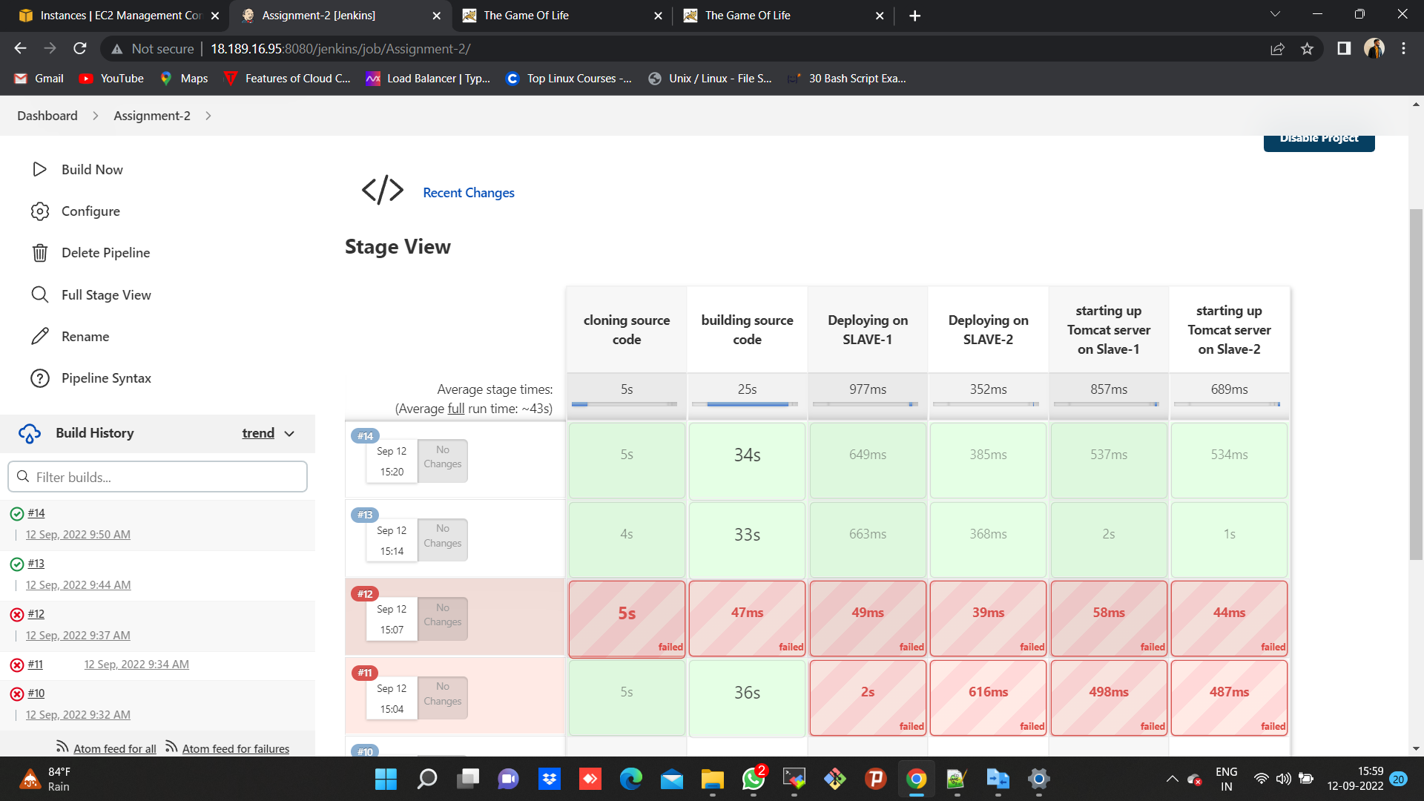

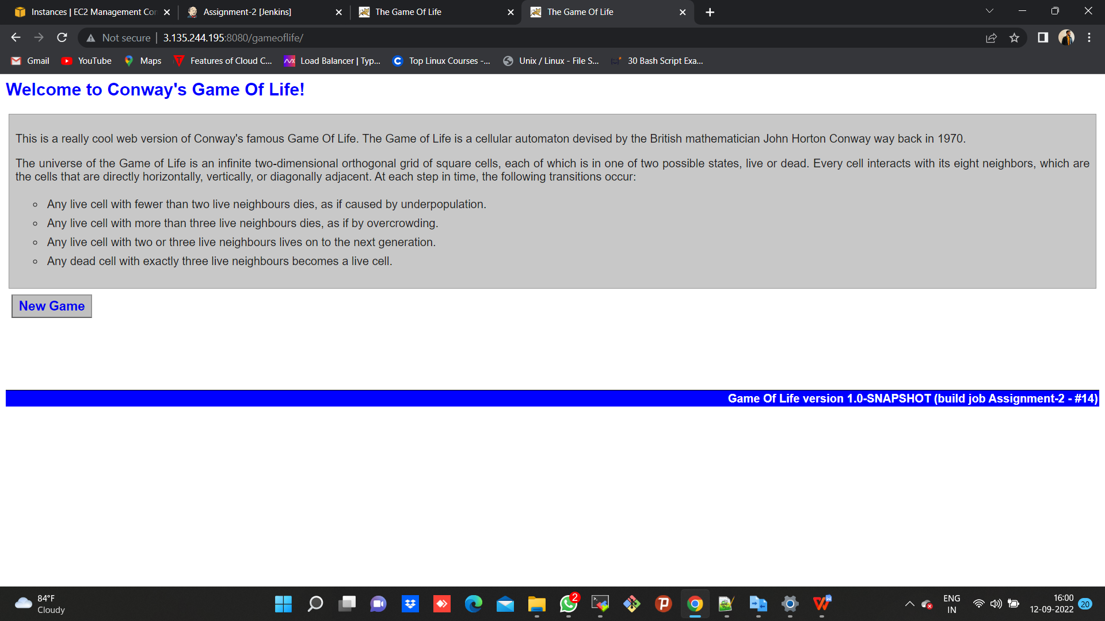

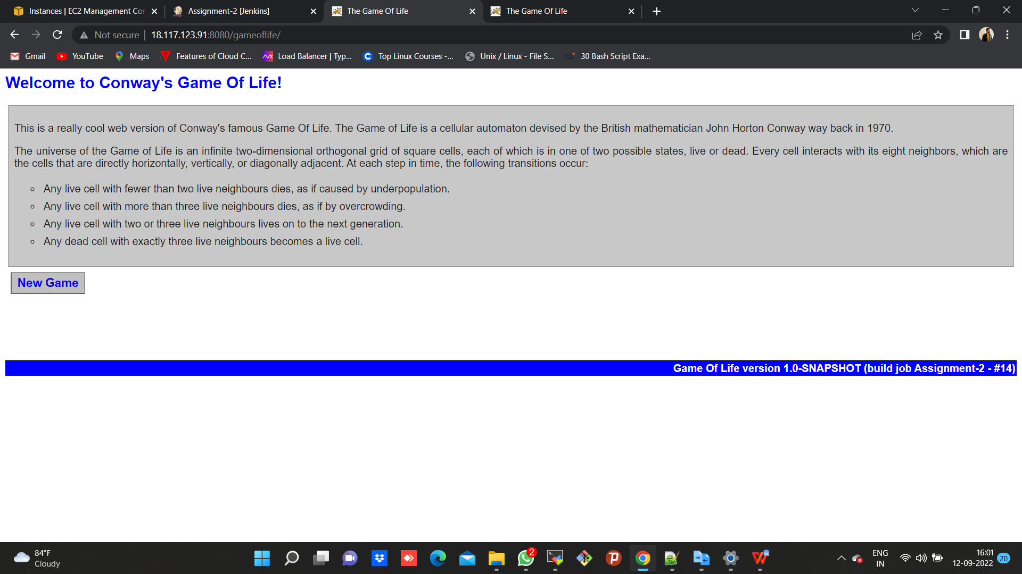

**CODE**

pipeline {

agent {

label {

label 'built-in'

customWorkspace '/mnt/projects'

}

}

stages {

stage ('cloning source code') {

steps {

sh "rm -rf *"

sh "yum install git -y"

sh "git clone https://github.com/nupur-londhe/game-of-life-nup.git"

sh "chmod 400 /mnt/ohio.pem"

}

}

stage ('building source code') {

steps {

dir ('/mnt/projects/game-of-life-nup'){

sh "mvn install"

}

}

}

stage ('Deploying on SLAVE-1') {

steps {

dir ('/mnt/projects/game-of-life-nup') {

sh "cp /mnt/ohio.pem /mnt/projects/game-of-life-nup"

sh "scp -i ohio.pem gameoflife-web/target/gameoflife.war ec2-user@172.31.28.75:/mnt/servers/apache-tomcat-9.0.65/webapps"

}

}

}

stage ('Deploying on SLAVE-2') {

steps {

dir ('/mnt/projects/game-of-life-nup') {

sh "scp -i ohio.pem gameoflife-web/target/gameoflife.war ec2-user@172.31.30.34:/mnt/servers/apache-tomcat-9.0.65/webapps"

}

}

}

stage ('starting up Tomcat server on Slave-1') {

agent {

node {

label "172.31.28.75-Slave-1"

customWorkspace "/mnt/servers/apache-tomcat-9.0.65/bin"

}

}

steps {

sh "bash startup.sh" //bash or sh to be used//

}

}

stage ('starting up Tomcat server on Slave-2') {

agent {

node {

label "172.31.30.34-Slave-2"

customWorkspace "/mnt/servers/apache-tomcat-9.0.65/bin"

}

}

steps {

sh "bash startup.sh" //bash or sh to be used//

}

}

}

}